**Task 2.1 P**

**SIT 210 -Embedded Systems**

**Aruj Punia 2310994767**

**Webhooks**

Webhooks are special tools that let different web services talk to each other instantly by sending information when specific things happen. Unlike APIs, which need to check for updates regularly, webhooks automatically send data to a chosen URL as soon as an event occurs. This makes them super quick and efficient.

One common example of webhooks in action is in online shopping. When someone buys something from an online store, the store can send a webhook to the shipping service's URL. This way, the shipping service gets notified right away about the new order, starting the shipping process without anyone having to do it manually. This helps make order delivery smoother and keeps customers updated about their purchases.

**LINK TO THE CODE - https://github.com/puniaruj/SIT-210--Embedded-Systems/tree/main/Task%202.1P**

**Circuit-**

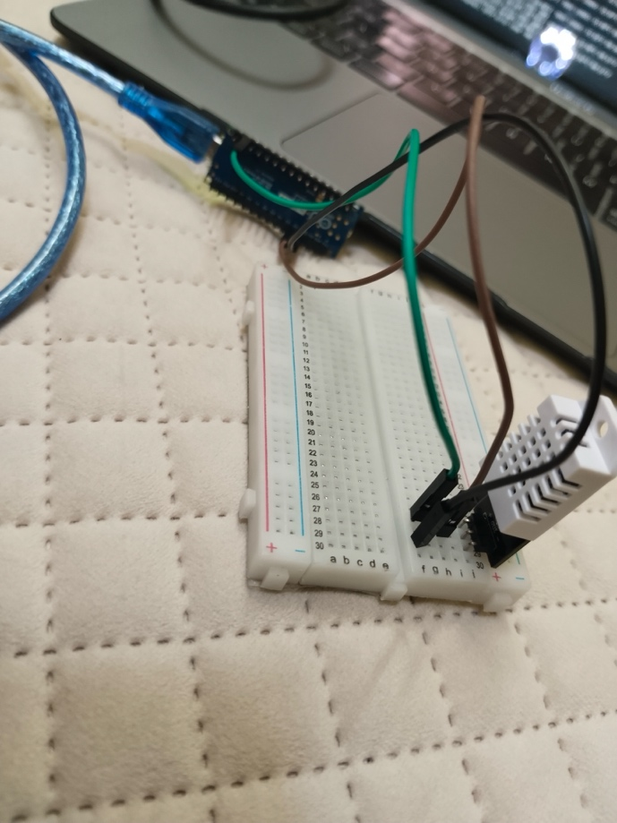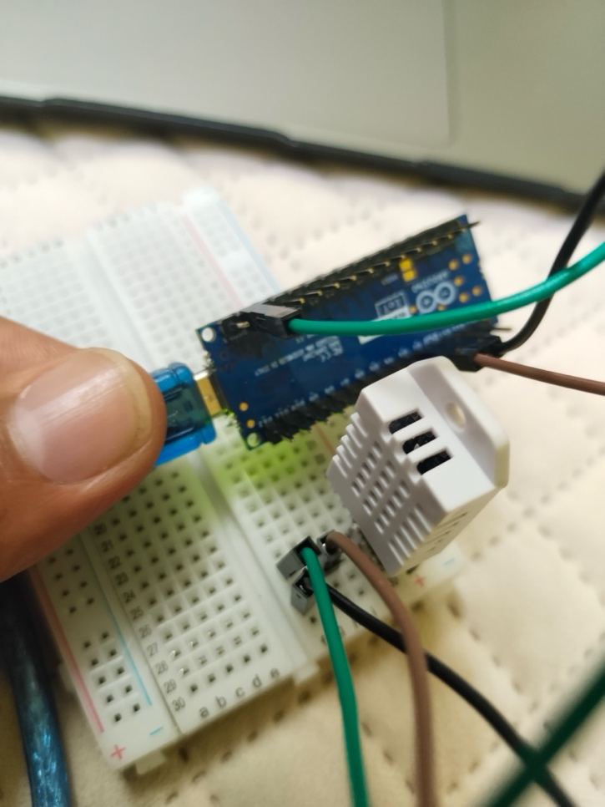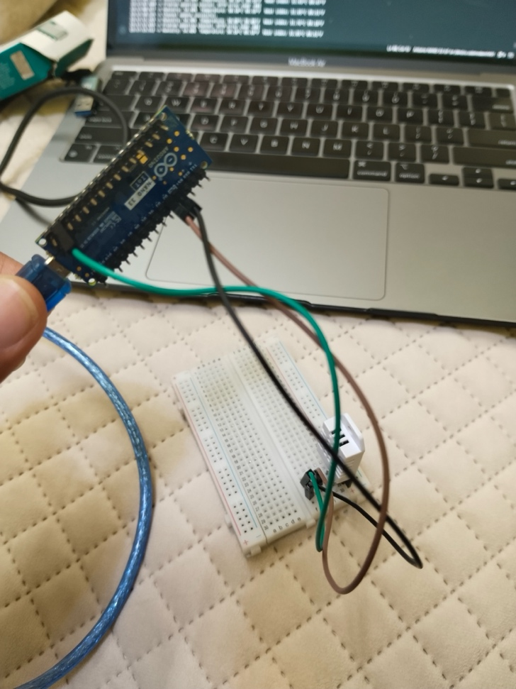

**THING SPEAK Channel View –**

**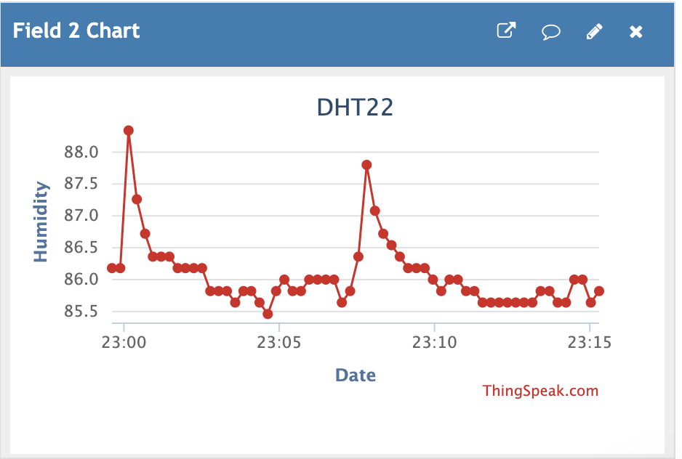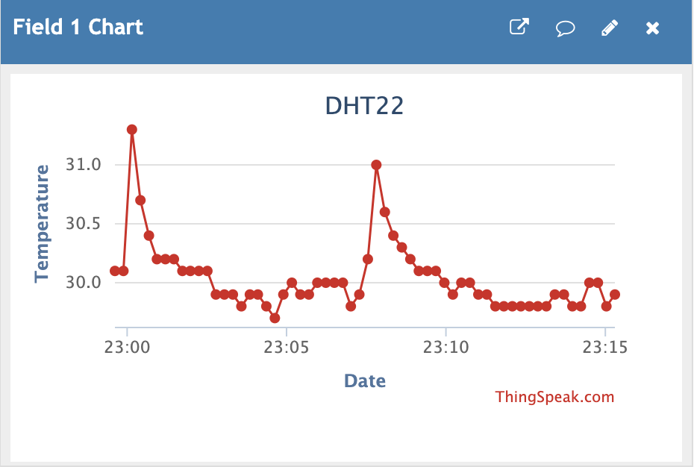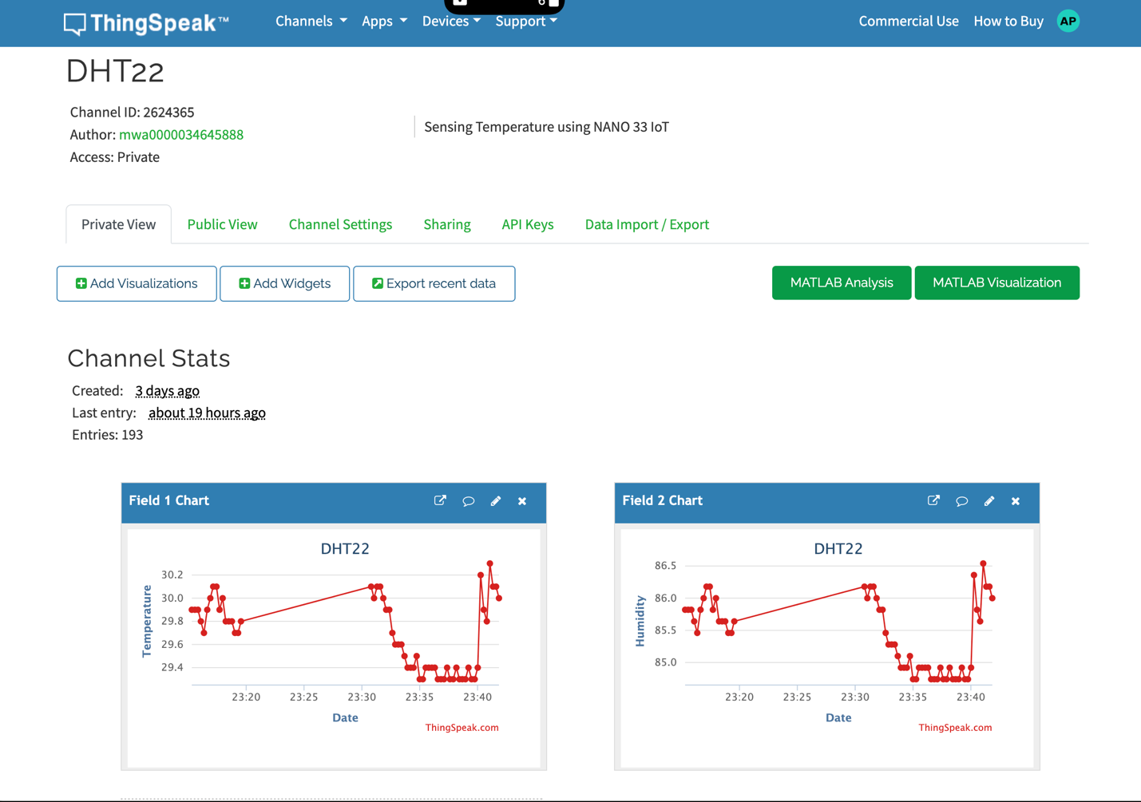  
  
INDVIDUAL CHARTS -**